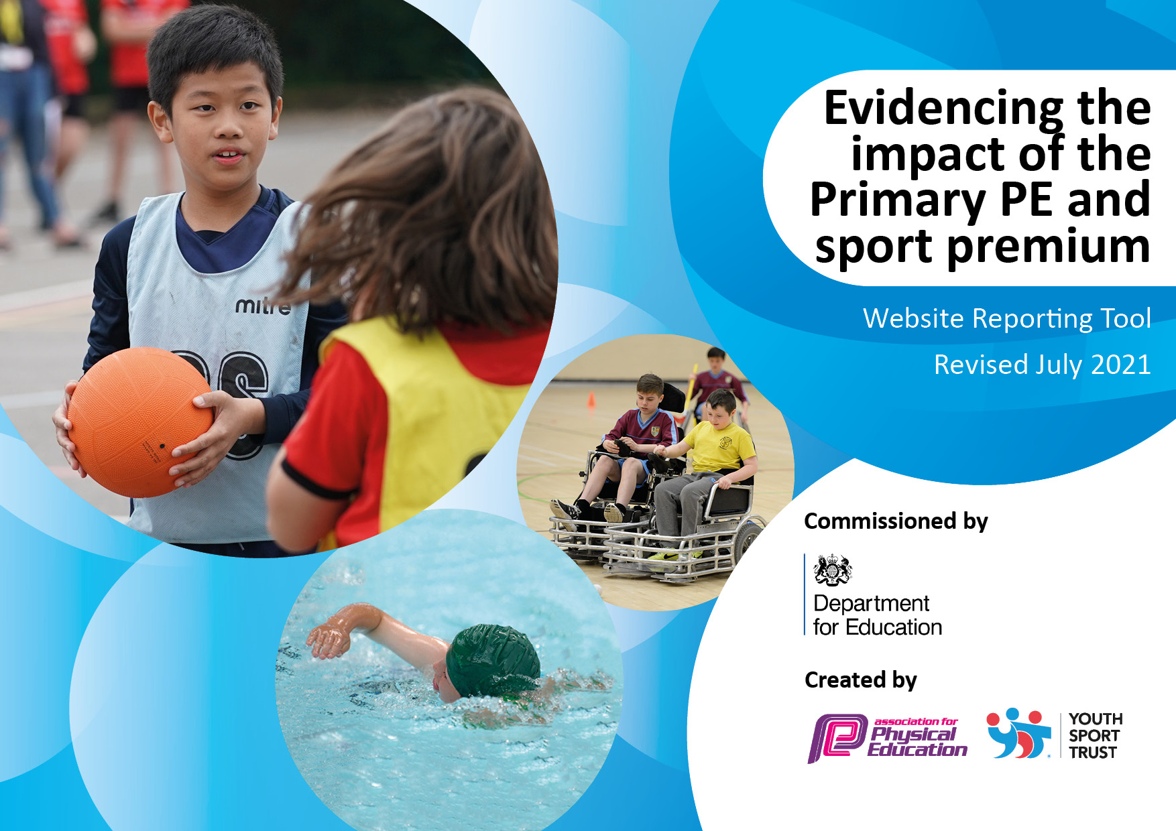
Stubbins Primary School 2022-23
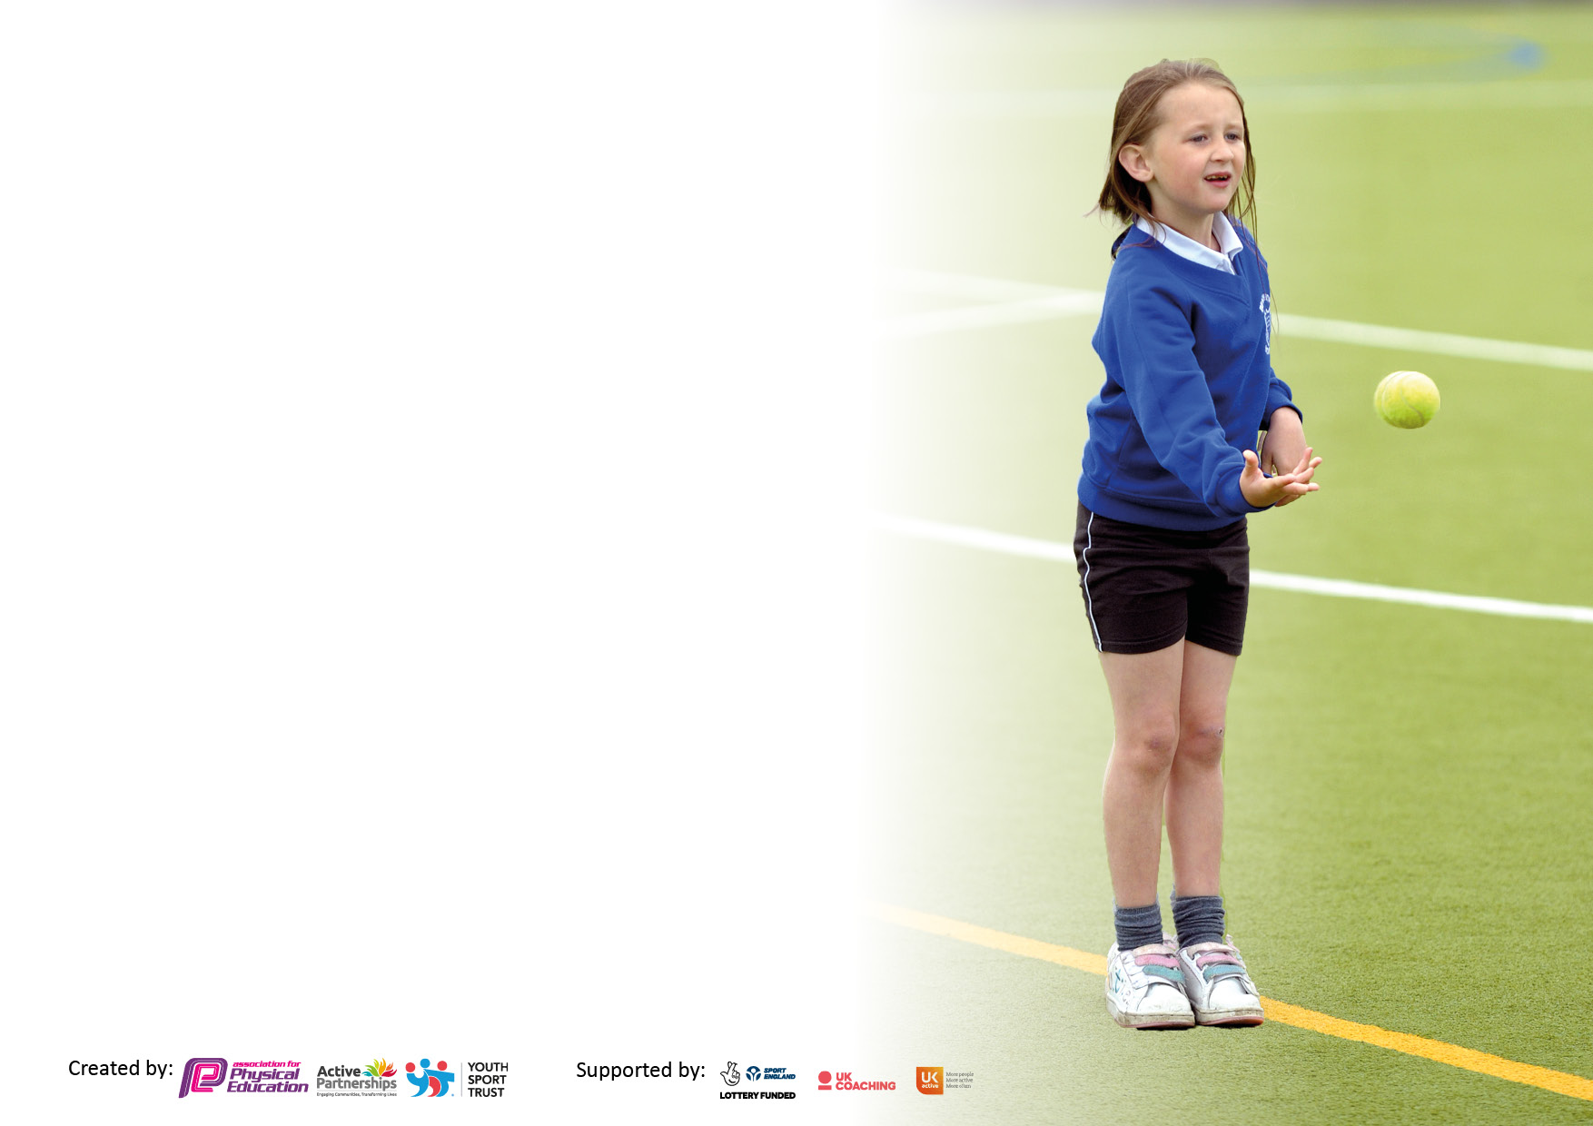

It is important that your grant is used effectively and based on school need. The Education Inspection Framework makes clear there will be a focus on ‘whether leaders and those responsible for governors all understand their respective roles and perform these in a way that enhances the effectiveness of the school’.

Under the Quality of Education Ofsted inspectors consider:
Intent - Curriculum design, coverage and appropriateness
Implementation - Curriculum delivery, Teaching (pedagogy) and Assessment
Impact - Attainment and progress

To assist schools with common transferable language this template has been developed to utilise the same three headings which should make your plans easily transferable between working documents.

Schools must use the funding to make additional and sustainable improvements to the quality of Physical Education, School Sport and Physical Activity (PESSPA) they offer. This means that you should use the Primary PE and sport premium to:

- Develop or add to the PESSPA activities that your school already offer
- Build capacity and capability within the school to ensure that improvements made now will benefit pupils joining the school in future years
- The Primary PE and sport premium should not be used to fund capital spend projects; the school’s budget should fund these.

Pleasevisitgov.ukfortherevisedDfEguidanceincludingthe5keyindicatorsacrosswhichschoolsshoulddemonstrate animprovement.Thisdocumentwillhelpyoutoreviewyourprovisionandtoreportyourspend.DfEencouragesschools to use this template as an effective way of meeting the reporting requirements of the Primary PE and sport premium.

We recommend you start by reflecting on the impact of current provision and reviewing the previous spend.

Schools are required to publish details of how they spend this funding, including any under-spend from 2019/2020, as well as on the impact it has on pupils’ PE and sport participation and attainment. All funding must be spent by 31st July 2022.

We recommend regularly updating the table and publishing it on your website throughout the year. This evidences your ongoing self-evaluation of how you are using the funding to secure maximum, sustainable impact. Final copy must be posted on your website by the end of the academic year and no later than the 31st July 2021. To see an example of how to complete the table please click HERE.
Created by: Supported by:

Details with regard to funding
Please complete the table below.

Total amount carried over from 2021/22 | £0
Total amount allocated for 2022-23 | £17, 790
How much (if any) do you intend to carry over from this total fund into 2023/24? | £4,964.94
Total amount allocated for 2023/24. | £17,700
Total amount of funding for 2023/24. To be spent and reported on by 31st July 2024. | £22,664.94
Swimming Data
Please report on your Swimming Data below.

Meeting national curriculum requirements for swimming and water safety.  N.B. Complete this section to your best ability. For example you might have practised safe self-rescue techniques on dry land which you can then transfer to the pool when school swimming restarts.  Due to exceptional circumstances priority should be given to ensuring that pupils can perform safe self rescue even if they do not fully meet the first two requirements of the NC programme of study | 12,825.06
What percentage of your current Year 6 cohort swim competently, confidently and proficiently over a distance of at least 25 metres?  N.B. Even though your pupils may swim in another year please report on their attainment on leaving primary school at the end of the summer term 2021.  Please see note above | 86%
Schools can choose to use the Primary PE and sport premium to provide additional provision for swimming but this must be for activity over and above the national curriculum requirements. Have you used it in this way? | No

Action Plan and Budget Tracking
Capture your intended annual spend against the 5 key indicators. Clarify the success criteria and evidence of impact that you intend to measure to evaluate for pupils today and for the future.

Academic Year: 2022/23 | Total fund allocated: £17,790 | Date Updated: April 2023
Key indicator 1: The engagement of all pupils in regular physical activity – Chief Medical Officers guidelines recommend that primary school pupils undertake at least 30 minutes of physical activity a day in school |  |  |  | Percentage of total allocation:
 |  |  |  | 38%
Intent | Implementation |  | Impact
Your school focus should be clear what you want the pupils to know and be able to do and about  what they need to learn and to  consolidate through practice: | Make sure your actions to achieve are linked to your intentions: | Funding allocated: | Evidence of impact: what do pupils now know and what can they now do? What has changed? | Sustainability and suggested next steps:
Least active children in school to be targeted at dinner times and encouraged to take part in physical activities.  Offer more opportunities for all children to be physically active and improve their fundamental movement skills.  Increase the activity levels of children in subjects throughout the curriculum. | Sports cool staff to run activities daily at dinnertime. Staff to be given a register and tick off the names of children who are taking part. Children who are seen to not be getting involved will be asked which activities they would like to do in the future  New equipment to be purchased for the Key Stage 1 and 2 playground that focusses on fundamental movement skills (FMS). Equipment to be purchased for each FMS. All teachers who spend time on the infant yard to be given training on how to effectively and safely use the equipment. Playground buddies to be trained up on how to use the equipment so they can help children when developing their FMS. A rota to be made for the equipment to ensure each FMS is being focussed on throughout the week. Resources to also be bought to ensure full P.E. curriculum can be taught.  A member of staff to go on Active Learning course on Tuesday 7th February. Information to be fed back to wider school staff in a staff meeting. | £5,163.20 for payments of Sports cool  £1641.91 payment of equipment  Cost implication is part of RSSP funding stated below. | Hard to pinpoint ‘least active’ children effectively but more children have been taking part in clubs at dinner times. School council had an involvement in selecting activities to do during the clubs.  New equipment has been purchased but has not yet been introduced onto the school playgrounds. This will happen in September.  Active learning is more of a focus with ideas being regularly shared between staff. | Use MOKI bands next year as a more effective and accurate way of pinpointing least active children.  Introduce new playtime equipment and assess if it is having an impact on the children’s activity lessons by gathering feedback from pupils and staff and by looking at data on MOKI bands.  Dedicate regular staff meeting time to active learning to ensure this remains a focus moving forwards.
Key indicator 2: The profile of PESSPA being raised across the school as a tool for whole school improvement |  |  |  | Percentage of total allocation:
 |  |  |  | Less than 1%
Intent | Implementation |  | Impact
Your school focus should be clear what you want the pupils to know and be able to do and about  what they need to learn and to  consolidate through practice: | Make sure your actions to achieve are linked to your intentions: | Funding allocated: | Evidence of impact: what do pupils now know and what can they now do? What has changed?: | Sustainability and suggested next steps:
Children, staff and parents to hear about sporting activity that has taken place throughout school. This will hopefully encourage more children to take part in a range of sporting activities in and out of school.  Ensure gymnastics equipment is safe to teach the national curriculum | Sporting achievements are recognised and shared at end of week assemblies where children are given any certificates and medals. School sport to be a regular feature of the weekly school newsletter and Twitter page. Larger of children will take part in sporting clubs and competitions this year, with transport if required.  Arrange the service of indoor equipment so that gymnastics can be safely taught. | £140 cover costs of travel to sporting event.  £78 for service of equipment | All but 5 children in KS2 have taken part in a inter school competition or festival.  Equipment safe to use. | Continue this next year.  Conduct regular checks on equipment to ensure everything is safe to use.

Key indicator 3: Increased confidence, knowledge and skills of all staff in teaching PE and sport |  |  |  | Percentage of total allocation:
 |  |  |  | 32%
Intent | Implementation |  | Impact
Your school focus should be clear | Make sure your actions to | Funding | Evidence of impact: what do | Sustainability and suggested
what you want the pupils to know | achieve are linked to your | allocated: | pupils now know and what | next steps:
and be able to do and about | intentions: |  | can they now do? What has
what they need to learn and to |  |  | changed?:
consolidate through practice:
Lancashire P.E. Passport app to be used throughout school for planning and assessment.  Staff CPD to gain ideas of sport specific ideas. | Whole school training to be completed on Thursday 2nd February. The app will then be used throughout school and will help teachers to plan, deliver and assess lessons with greater confidence.  Staff to team teach and observe qualified sports coaches from Rossendale School Sport Partnership (RSSP)and transfer knowledge and skills learnt in their own lessons. Rossendale School Sport Partnership service level agreement. | £680 for subscription payments, which includes staff training  £4980 for the RSSP service level agreement | P.E. passport as been used by all staff in final term of this year. Feedback from all staff has been positive. | All lessons from September to be taught and assessed using the PE Passport app.
Key indicator 4: Broader experience of a range of sports and activities offered to all pupils |  |  |  | Percentage of total allocation:
 |  |  |  | Less than 1%
Intent | Implementation |  | Impact
Your school focus should be clear | Make sure your actions to | Funding | Evidence of impact: what do | Sustainability and suggested
what you want the pupils to know | achieve are linked to your | allocated: | pupils now know and what | next steps:
and be able to do and about | intentions: |  | can they now do? What has
what they need to learn and to |  |  | changed?:
consolidate through practice:
Increase the number of children throughout school taking part in extra-curricular sports. | Carry out a pupil survey with children.  Offer a range of sports in P.E. and offer a range of afterschool clubs and competitions to introduce as many students as possible to different sports. Try some new sports to engage pupils who have not yet been involved in sporting activity.  Purchase equipment to support the above. | £141.95 for purchase of tag rugby and Frisbee equipment | 123 children have attended after school clubs this year. Frisbee and tag rugby clubs both ran successfully and some children who had never been to a club before attended. | Gather pupil voice around which clubs they would like to see next year and buy any extra equipment needed to provide this.

Key indicator 5: Increased participation in competitive sport |  |  |  | Percentage of total allocation:
 |  |  |  | % part of RSSP
Intent | Implementation |  | Impact
Your school focus should be clear | Make sure your actions to | Funding | Evidence of impact: what do | Sustainability and suggested
what you want the pupils to know | achieve are linked to your | allocated: | pupils now know and what | next steps:
and be able to do and about | intentions: |  | can they now do? What has
what they need to learn and to |  |  | changed?:
consolidate through practice:
Give every child in Key Stage 2 the opportunity to take part in competitive sport. Tables to be kept keeping track of which students have taken part in competitions in and out of school. | Enter as many competitions as possible throughout the year and organise competitive fixtures with other schools. Throughout the year, any children who haven’t taken part in competitive sport will be encouraged and discussions around worries or sports they would like to take part in will be had. | Cost implication is part of RSSP funding stated above. | 385 children have attended a competition/festival this year and as a school we have taken part in 35 different events throughout the year. Only 5 children did not take part in an out of school sports event but every child has been given the opportunity. | Carry this on next year.

Signed off by
Head Teacher: | C Rawcliffe
Date: | May 2023
Subject Leader: | Mr Murtaugh
Date: | May 2023
Governor:
Date:

